**Q5-Ansible document**

**Organize structure**

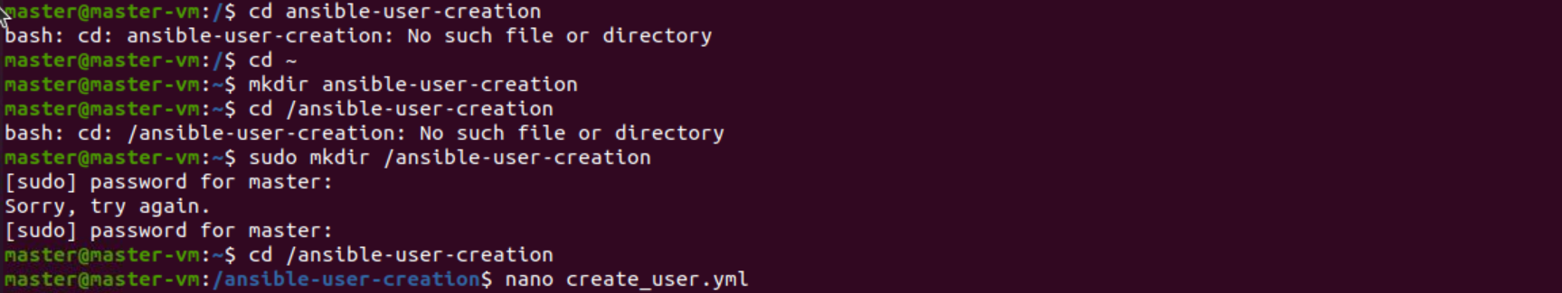

**Create user file**

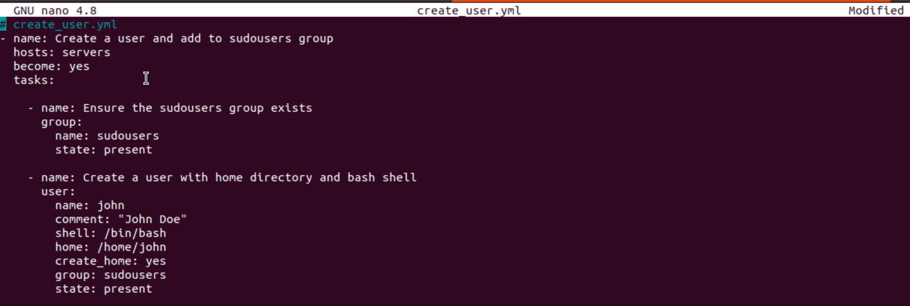

**Running the playbook**

